1. **Adding Navigation Bar**

* So we added all the components we created to our templates.
* I will use a couple of Bootstrap classes to create a nice looking header.
* So I'll create a wrapping nav element, and on this element I'll add the *class=”navbar navbar-default”.* These are just Bootstrap classes, which will give me this default Bootstrap header.

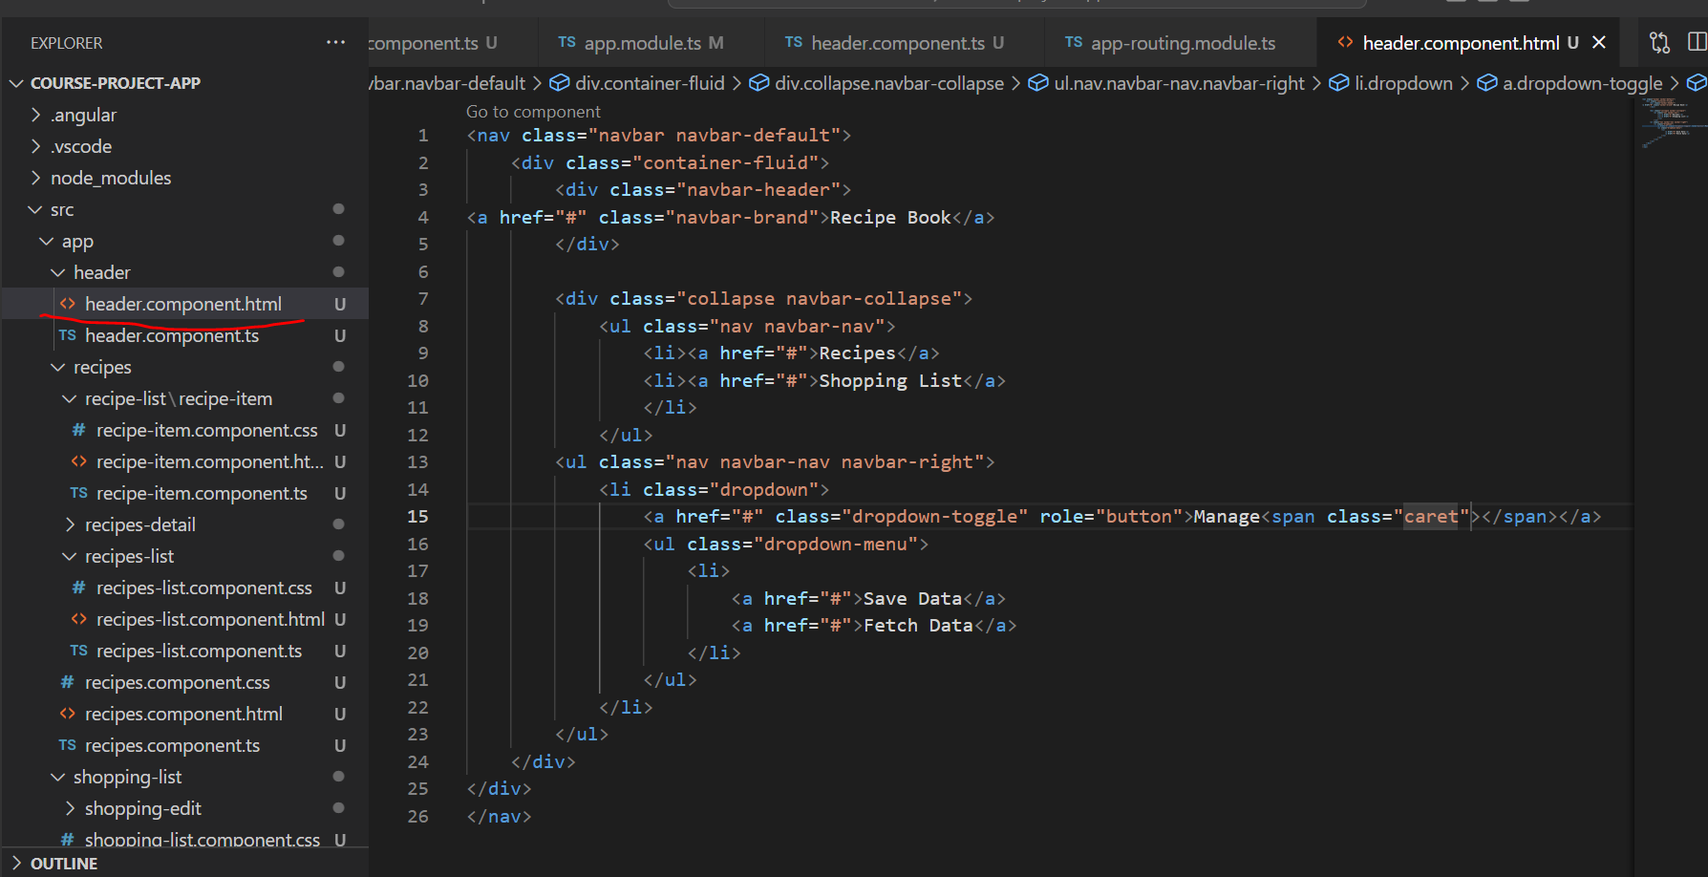

* In there, I'll place a container fluid div to have my own view container basically in there.
* And the first thing I want to have here is a header. For that, we got the navbar header class. we can add to a div. And in this div, I want to have a clickable header,
* so I'll add a anchor tag with pointing to hash for now. We'll later, of course, add a route there, once we learned how to do this, and this should have the class navbar brand to give this this brand-like textile. I'll say recipe book here, since this is the name of our application. So that's the header part of our header.
* so this main brand part. Now let's work on the actual links. For this, I'll add a div, which will receive the collapse class, and then the navbar collapse class. Now, I won't really use the collapse feature. I won't add a hamburger icon here since we will not have many links on our header anyways,but this gives us some nice styles.
* So in here(header.component.html), I now want to have a group of list items, so a group of links in the end. This will be an unordered list with the CSS classes nav, and then navbar nav. So make sure to create this unordered list with these classes.
* And in there, if we add some list items, they will actually sit next to each other, so they will automatically be positioned correctly by Bootstrap.
* Each list item should hold a link. So here I'll add a anchor tagalso pointing to just hash for now. One for the recipe section, and a second one for the shopping list section.
* Now with that added, I'll add another area in my header here. This will be another unordered list, which will receive the classes nav, and now also navbar nav like before, but then also navbar right to position these links at the right.
* And actually, this will only be one link here, which will receive a class of dropdown, this list item will, because later, we will add our own directive, which will turn this into a working dropdown where we can then choose some options to store our data on a server, something we'll also implement later in this course, or fetch it from there.
* So in this dropdown, I simply want to have my dropdown menu which, when using Bootstrap,is added by adding an unordered list with the class dropdown menu.
* So this will hold the items of this dropdown,and here I'll add a couple of list items, which all hold some links pointing to just hash for now. One for saving data, and one for fetching data. Again, this will be filled with working code later. So that's my header.
* which would open the dropdown.
* We will do this after the directives section, though.
* So, the header is now working with that.
* Let's move on, and let's work on our recipe section.

1. **Alternative Non-Collapsable Navigation Bar**

The way we added it, the Navbar will collapse on smaller screens. Since we didn't implement a Hamburger menu, that means that there's no way of accessing our links on smaller screens.

You can either add such a menu on your own (see below), or you replace collapse navbar-collapse  with just navbar-default.

Adding a Hamburger Menu:

Alternatively, if you want to make the navigation bar responsive, please replace these lines in header.component.html:

1. <div class="navbar-header">
2. <a routerLink="/" class="navbar-brand">Recipe Book</a>
3. </div>
4. <div class="collapse navbar-collapse">

with these lines:

1. <div class="navbar-header">
2. <button type="button" class="navbar-toggle" (click)="collapsed = !collapsed">
3. <span class="icon-bar" *ngFor="let iconBar of [1, 2, 3]"></span>
4. </button>
5. <a routerLink="/" class="navbar-brand">Recipe Book</a>
6. </div>
7. <div class="navbar-collapse" [class.collapse]="collapsed" (window:resize)="collapsed = true">

and add this line to header.component.ts:

1. collapsed = true;